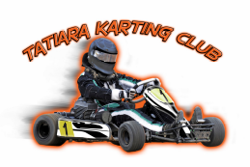
Bordertown, SA www.tatiarakartingclub.net.au
Tatiara Karting Club Inc
Membership Form 2021
PO Box 126 Keith SA 5267

New Member Membership Renewal Family Membership $60.00 Single $40.00

Please email form to secretary@tatiarakartingclub.net.au

Renewal payments can be made to Scott Williamson, Secretary – due before 30th Jan 2021
or EFT Payment to Tatiara Karting Club
BSB: 633 000 Acc: 158638783 Ref: Family Name
Memberships must be paid prior to obtaining an AIDKA Licence

Address
Email
Mobile 1 |  | Mobile 2

First Name | Surname | Licence No | Kart No

AIDKA Licences are to be renewed on-line www.aidka.com.au
*please note you must be a financial member of a club before you renew your AIDKA licences*

There are many volunteer positions within our club. Yearly rosters will be distributed to members. If you are unable to commit to your rostered time please make your own arrangements to swap with someone else. Rosters are key to help spread the workload.

Our club requests permissions for photos to be used in publications for the greater good of the Tatiara Karting Club.
Our club also offers opportunities for all members to be trained Race Day officials. Please let us know if you are interested

Please let us know if you are able to help at Race Meetings in any of the below areas
(Training available)

□ Steward □ Canteen □ First Aid

□ Scrutineering □ Lap scoring □ Sponsorship

